6.4: a) The friction force to be overcome is

or 74 N to two figures.

b) From Eq. (6.1), 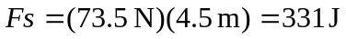. The work is positive, since the worker is pushing in the same direction as the crate’s motion.

c) Since f and s are oppositely directed, Eq. (6.2) gives

d) Both the normal force and gravity act perpendicular to the direction of motion, so neither force does work. e) The net work done is zero.

